Task on Docker-03
- Create a image from running container.
- To create a new Docker image from an existing running container in order to preserve its current state, configurations, and changes.
- Step by step Implementation:
- Step 1: Pull NGINX image
docker pull nginx:latest
- Step 2: Run NGINX container
docker container run -itd -p 8080:80 --name nginx-container nginx:latest

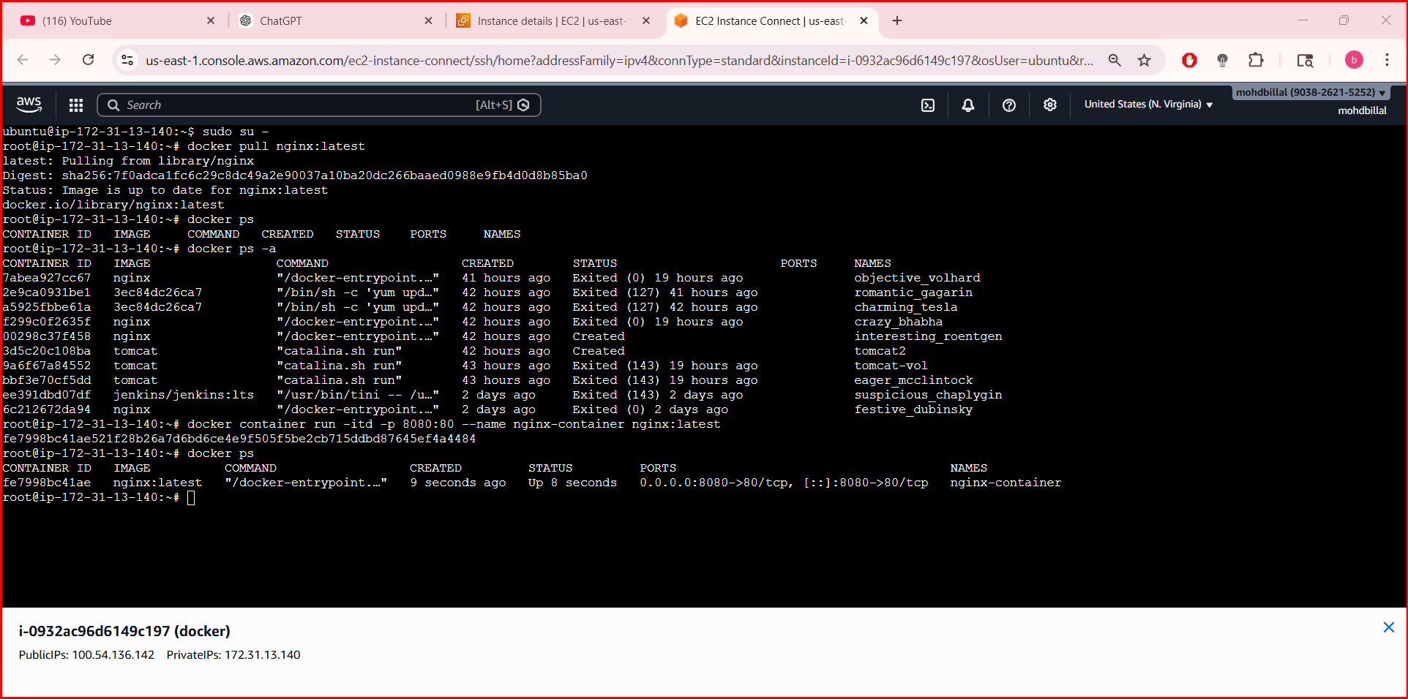
- Step 3: Enter running container
docker exec -it nginx-container /bin/bash
- Step 4: Modify NGINX default page
- echo "<h1>NGINX Image Created from Running Container</h1>" >
- /usr/share/nginx/html/index.html
- exit

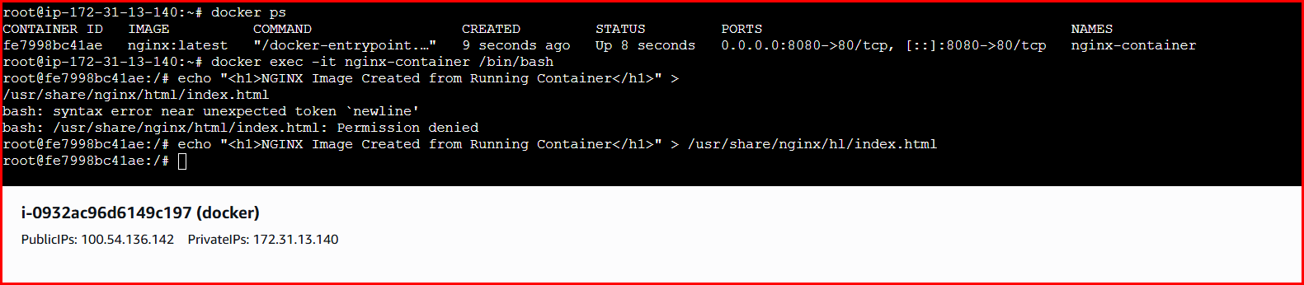
Step 5: Create image from container
- docker commit nginx-container custom-nginx:v1

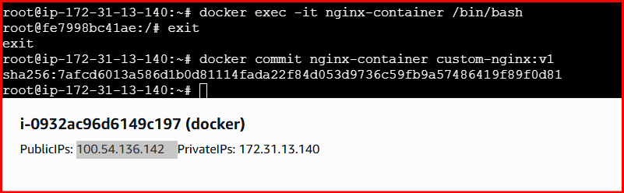
Validation:Done
- By committing the running container to a Docker image, the environment can be easily reused, shared, or redeployed without repeating the original setup steps.

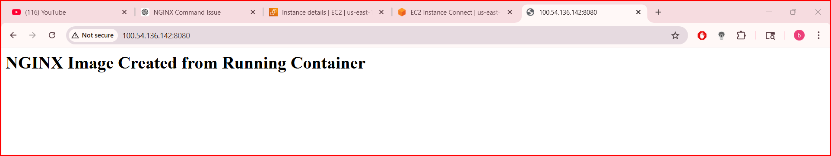
2.Create Docker image using alpine and customize with tomcat.
- To create a lightweight Docker image using Alpine Linux and customize it by installing and configuring Apache Tomcat for running Java web applications.
- Step by step implementation
- Mkdir alpine-tomcat
- Cd alpine-tomcat
- nano Dockerfile
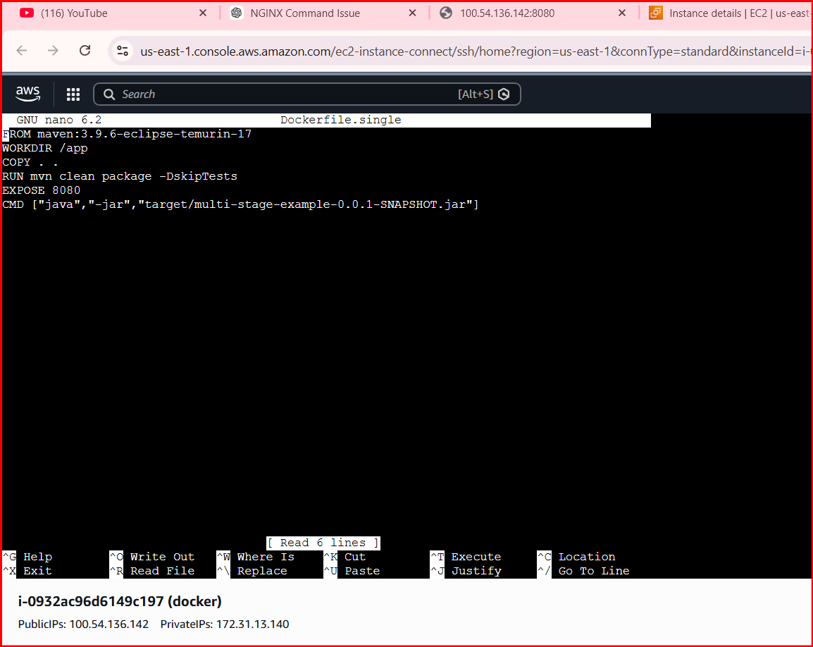

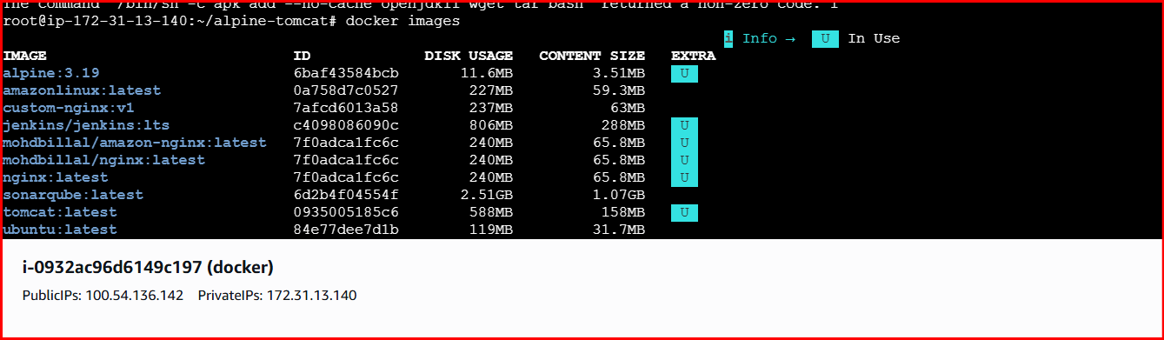

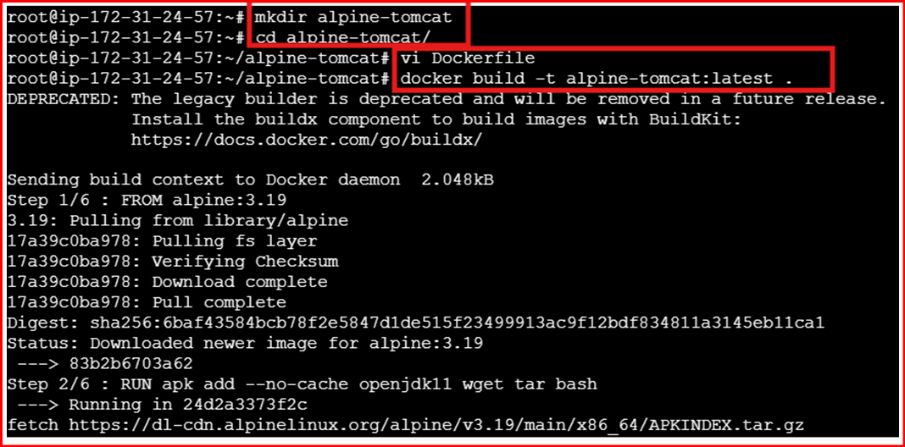

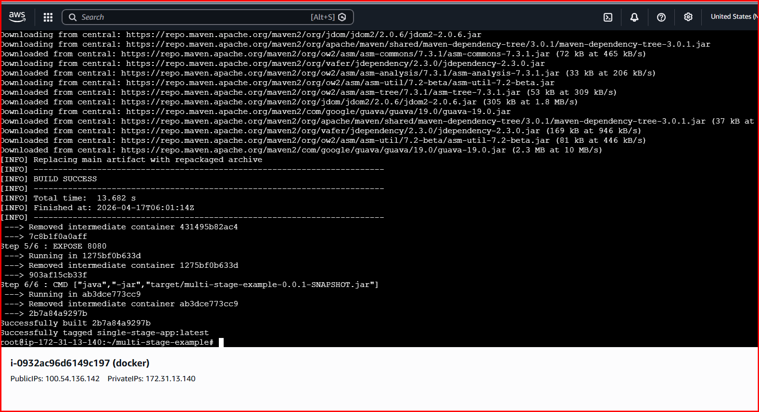


- docker run -d -p 8080:8080 --name tomcat alpine-tomcat:latest

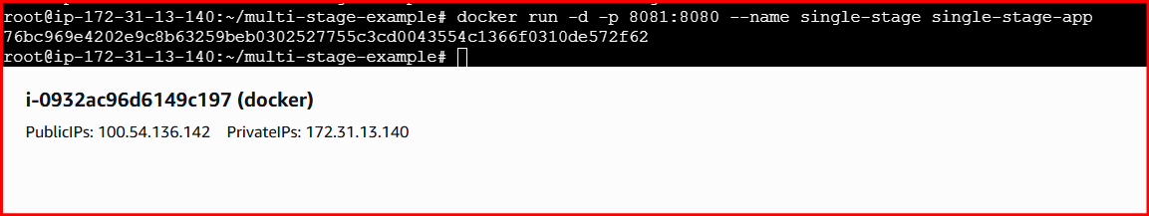
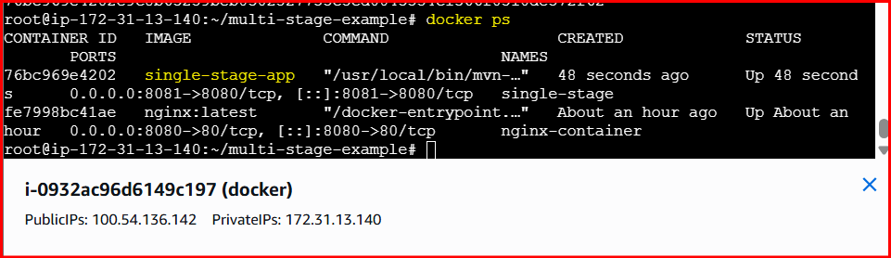

Validation:
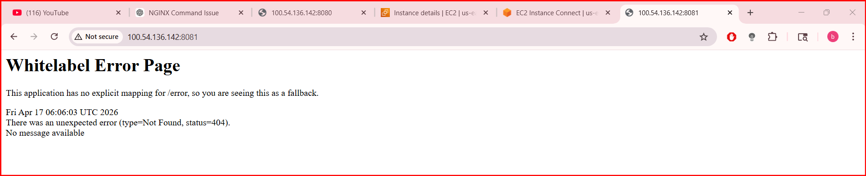
3.Multi-Stage Dockerfile Create single stage and multi stage docker file using this source code: \
https://github.com/betawins/multi-stage-example.git
- vi Dockerfile.multi
- FROM maven:3.9.6-eclipse-temurin-17 AS builder
- WORKDIR /app
- # Copy pom first to cache dependencies
- COPY pom.xml .
- RUN mvn dependency:go-offline
- # Copy source code
- COPY src ./src
- RUN mvn clean package -DskipTests
- FROM eclipse-temurin:17-jre-alpine
- WORKDIR /app
- # Copy jar from builder stage
- COPY --from=builder /app/target/*.jar app.jar
- # Expose application port
- EXPOSE 8083
- CMD ["java","-jar","app.jar"]

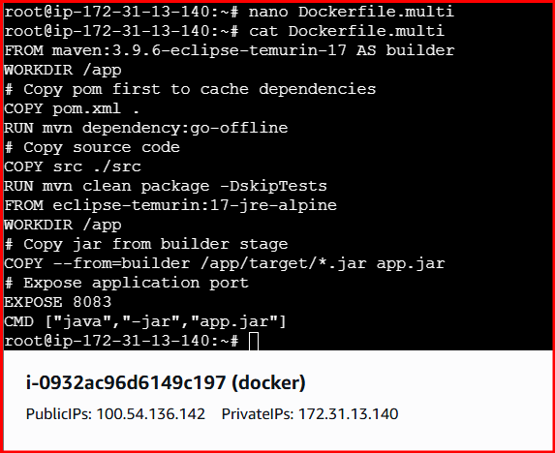
Build multi-stage image
- docker build -f Dockerfile.multi -t multi-stage-app .

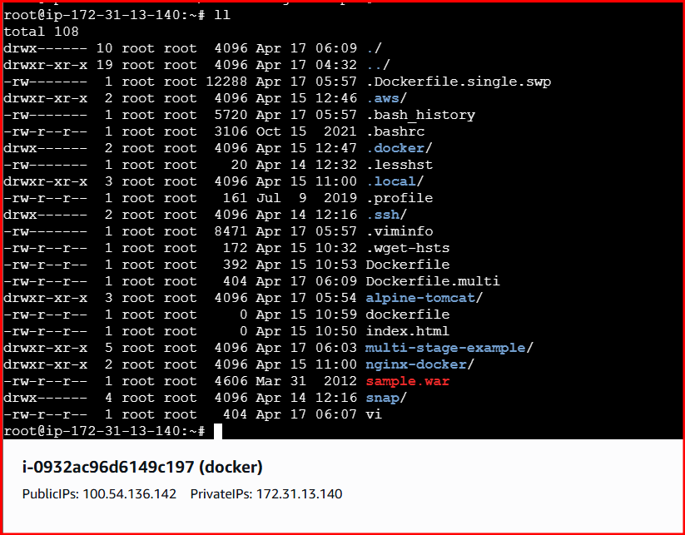
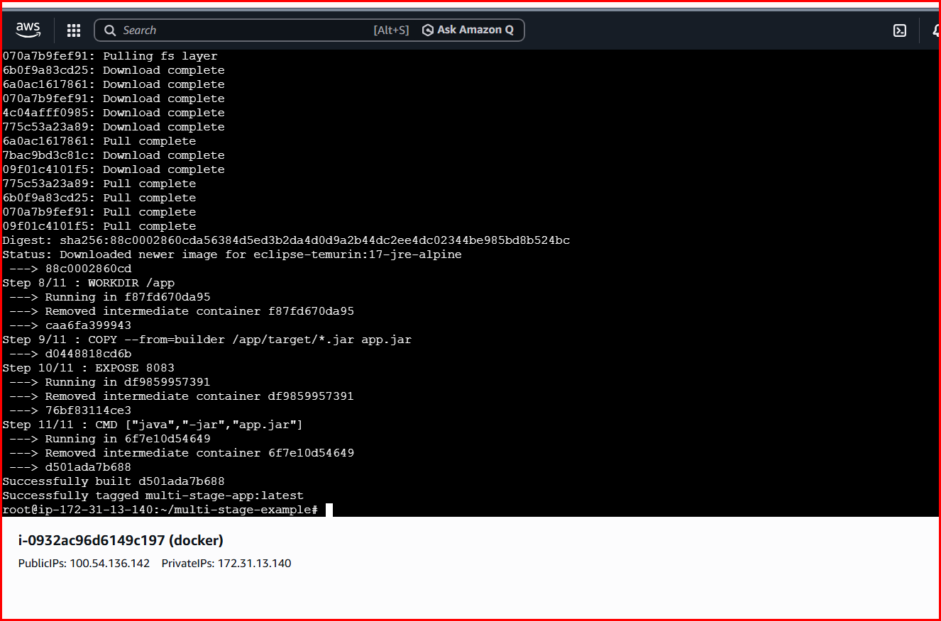
Run Container
- docker run -d -p 8083:8080 --name multi-stage multi-stage-app

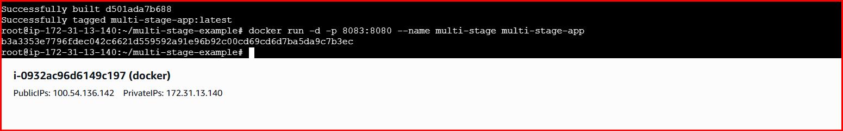
Validation
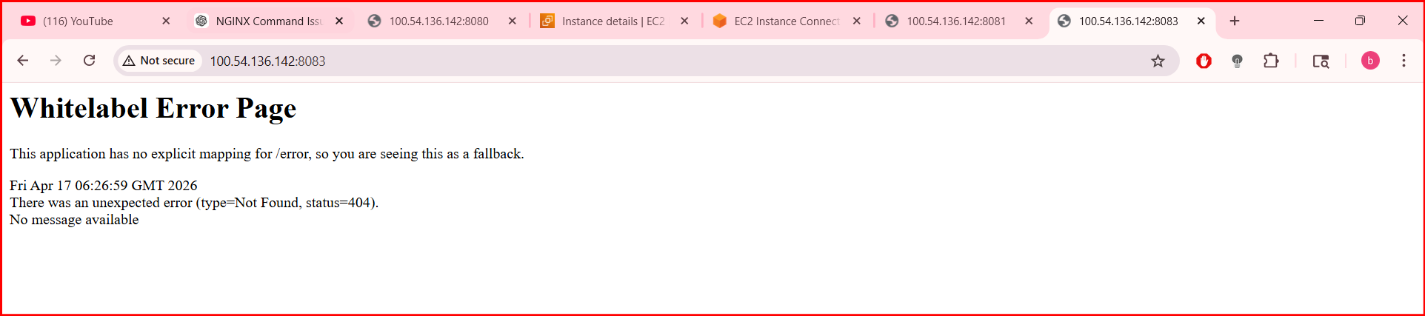
Conclusion
- Single-stage Dockerfiles are simple but result in larger images
- Multi-stage Dockerfiles remove unnecessary build dependencies
- Multi-stage builds are more efficient and suitable for production use

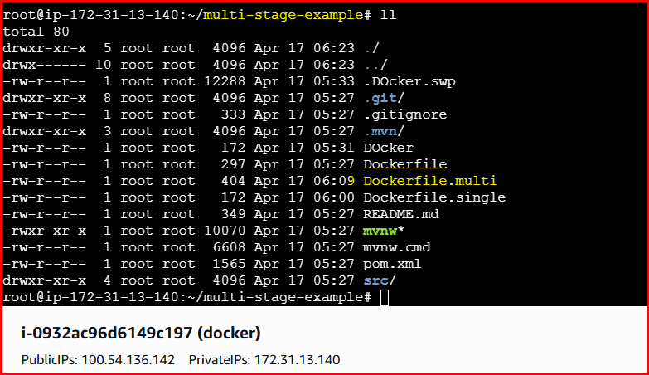
4.Install docker compose and execute sample application.
- To install Docker Compose on the system
- To understand how Docker Compose manages multi-container applications
- To run and verify a sample application using Docker Compose
Step by Step Implementation:
Step 1: Install Docker Compose
- sudo curl -L https://github.com/docker/compose/releases/latest/download/docker-compose-linux-x86_64 \
- -o /usr/local/bin/docker-compose
- sudo chmod +x /usr/local/bin/docker-compose

Step 2: Verify installation
- docker-compose version

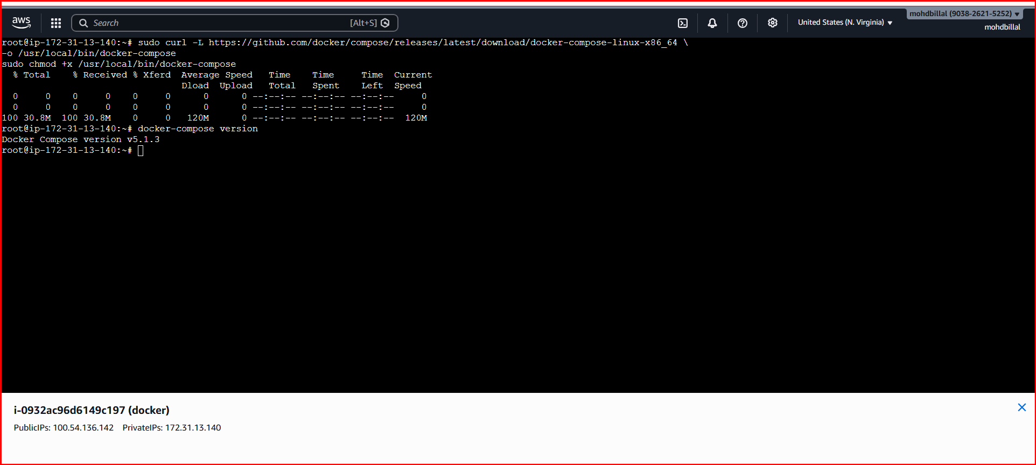
Step 3: Create docker-compose.yml
- vi docker-compose.yml
Step 4: Add content
- version: "5.0.2"
- services:
- web:
- image: nginx
- ports:
  - "8085:80"

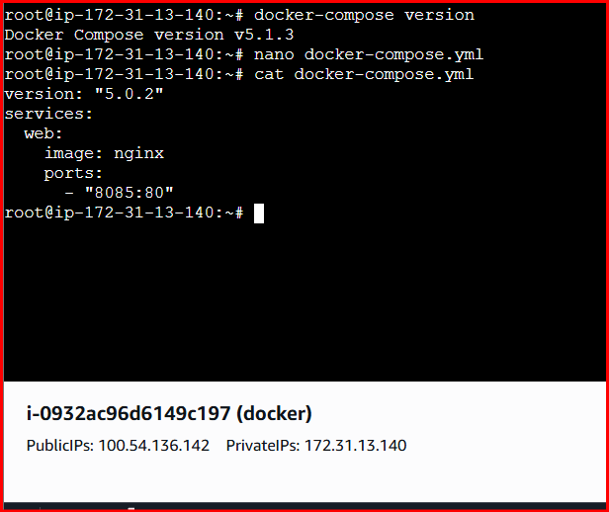
Step 5: Run application
- docker-compose up -d

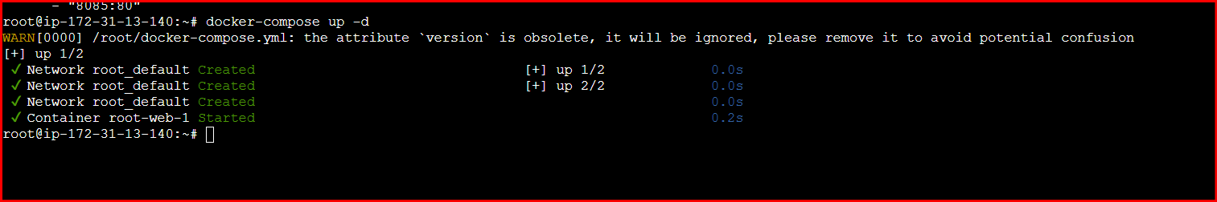
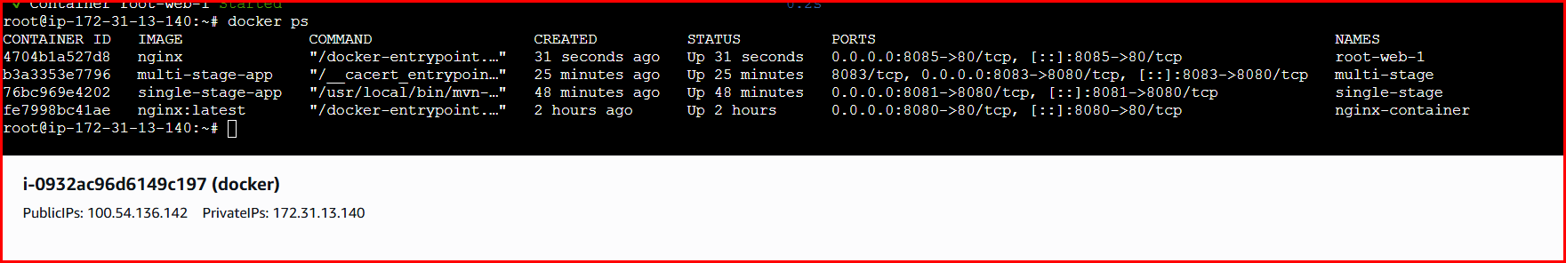
Validation

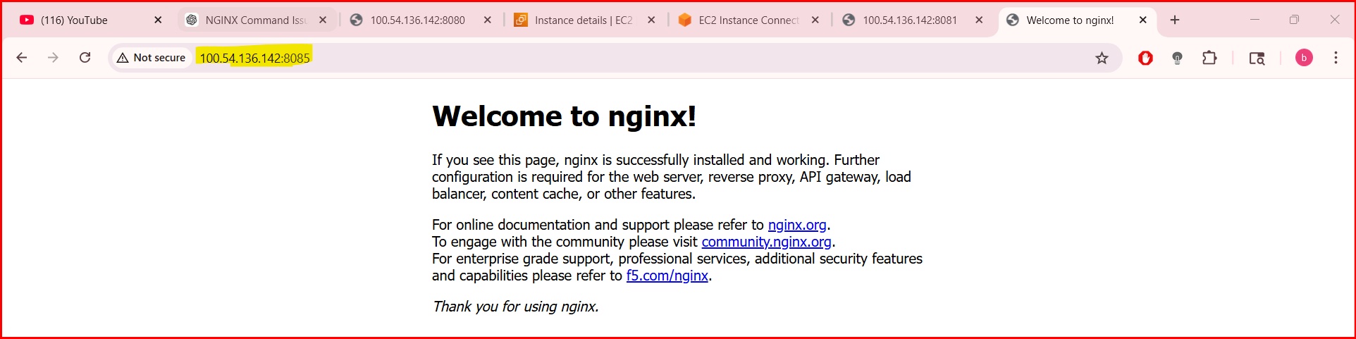
Conclusion
- Docker Compose simplifies application deployment
- Services can be started with a single command
- Docker Compose improves development and testing efficiency

5. Implement solution to scan images hen pushed to docker registry.
Objective
- To implement an automated solution for scanning Docker images
- To detect vulnerabilities when images are pushed to a Docker registry
- To improve container security in the CI/CD pipeline
Step by Step Implementation:
Step 1: Enable Image Security Scanning in Docker Hub
- Log in to Docker Hub.
- Navigate to:
- Repositories → <username>/<repository> → Settings
Under Image security insight settings, select:
- Docker Scout image analysis (Recommended)
Click Save.

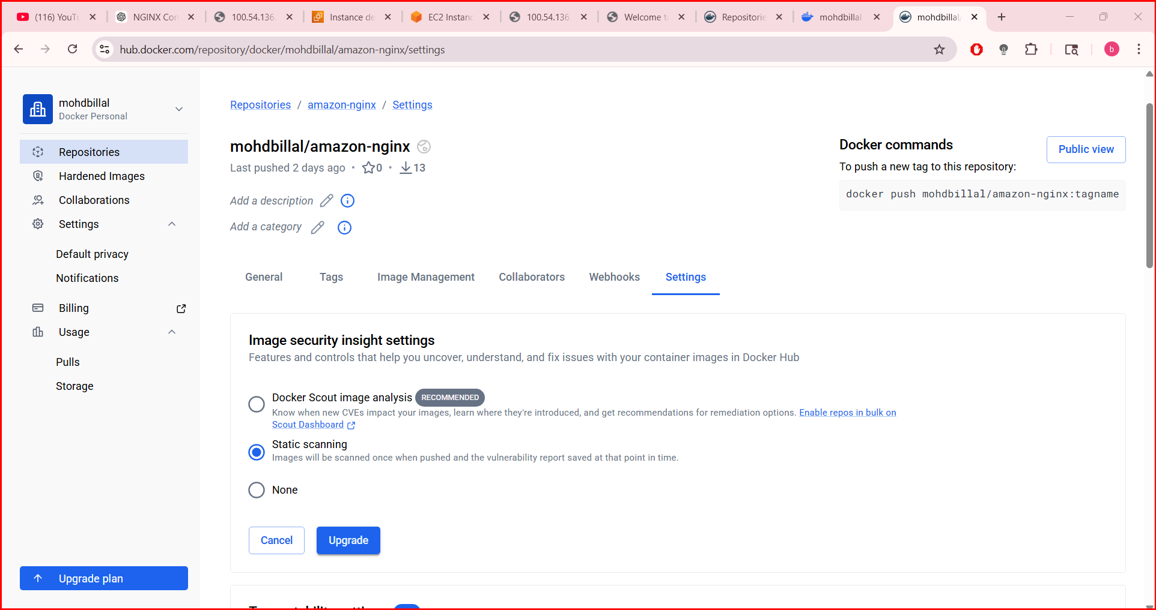
Step 2: Authenticate to Docker Hub from the CLI
Docker login

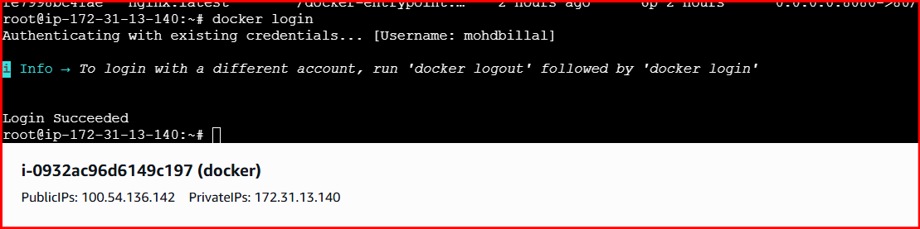
Step 3: Navigate to the Application Source Directory
- cd multi-stage-example
- ls -l

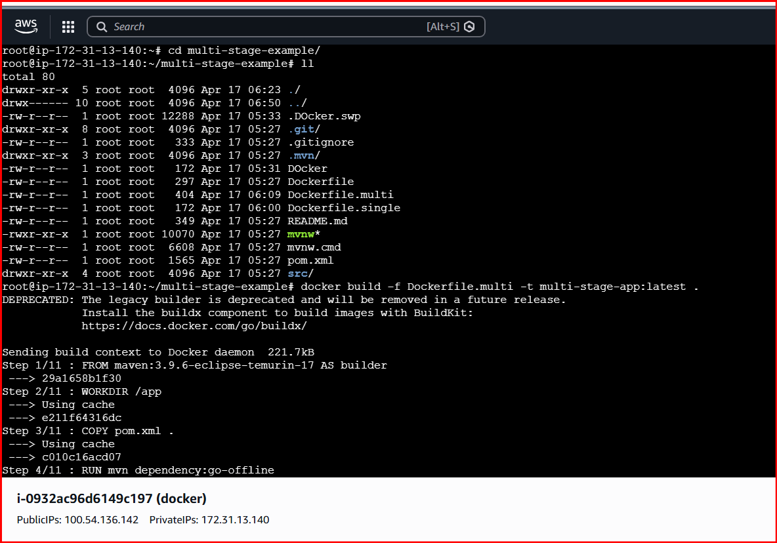
Step 4: Build the Multi-Stage Docker Image
- docker build -f Dockerfile.multi -t multi-stage-app:latest .

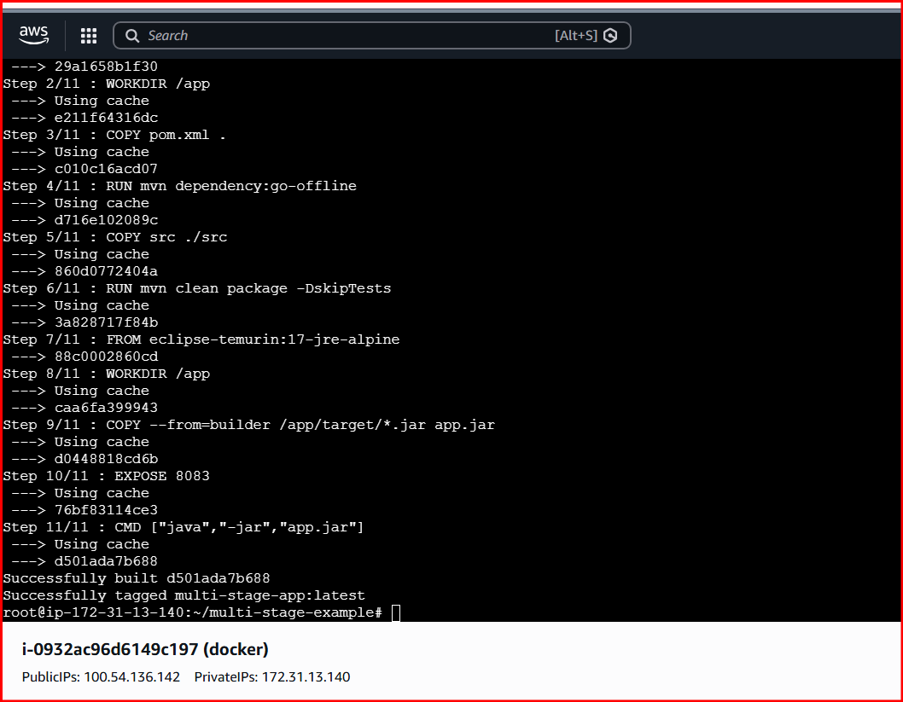
Step 5: Verify Built Images Locally
Step 6: Tag the Image for Docker Hub
- docker tag multi-stage-app:latest <dockerhub-username>/devops:1.0

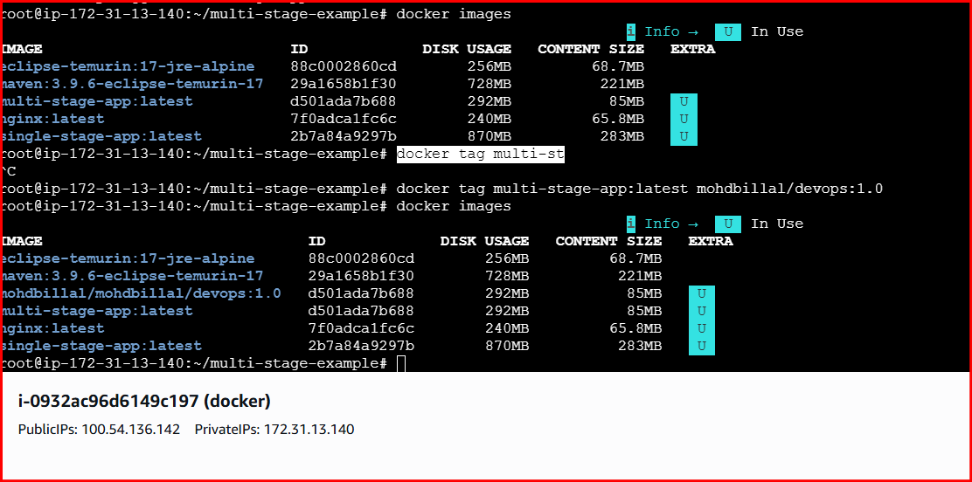
Step 7: install trivy and Scan the Image Locally with Trivy
- Tool Used
- Trivy (popular open-source container vulnerability scanner)
- Download Trivy binary (latest stable)
- sudo apt-get update
- sudo apt-get install -y wget
- wget https://github.com/aquasecurity/trivy/releases/latest/download/trivy_0.48.3_Linux-64bit.tar.gz
- Verify installation
- trivy --version

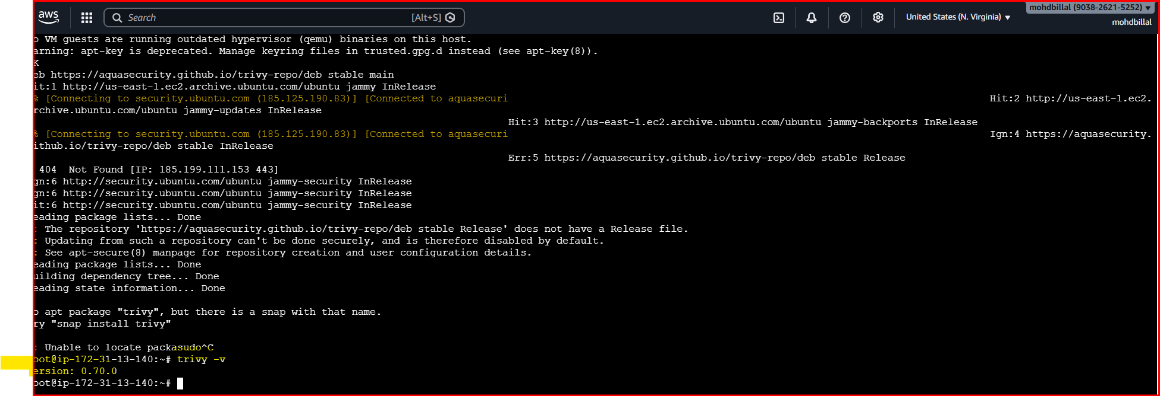
Now scan your Docker image
- trivy image <dockerhub-username>/devops:1.0

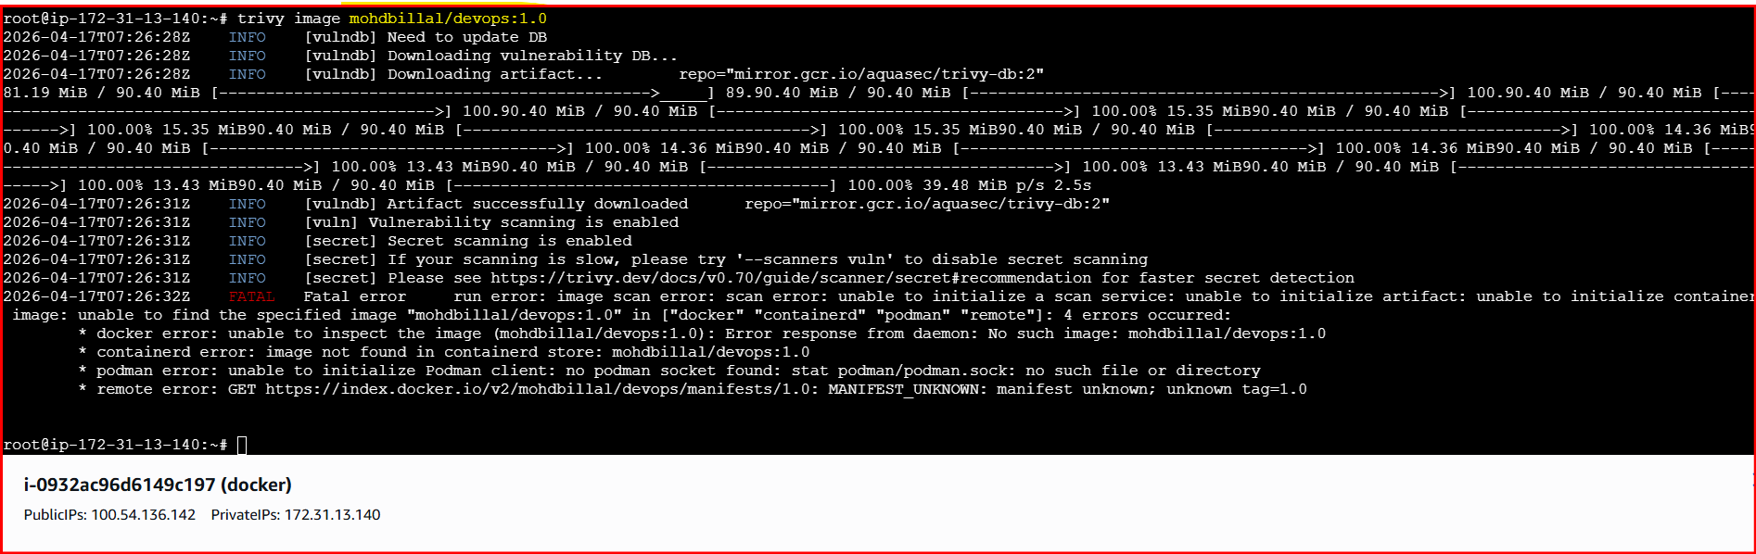
Step 8: Push the Image to Docker Hub
- docker push <dockerhub-username>/devops:1.0

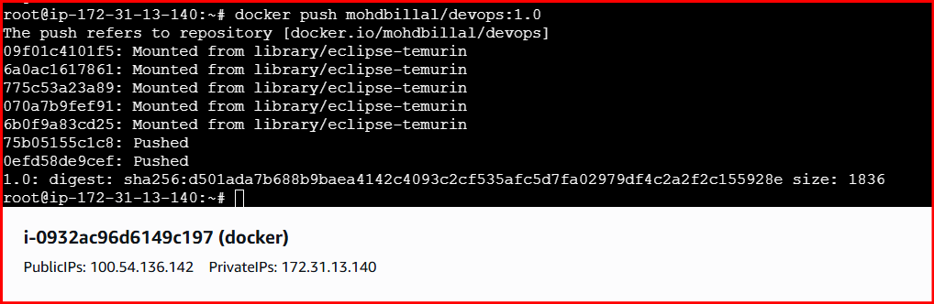

Step 9: Verify Image in Docker Hub Repository
- Docker Hub → Repositories → <username>/devops → Tags

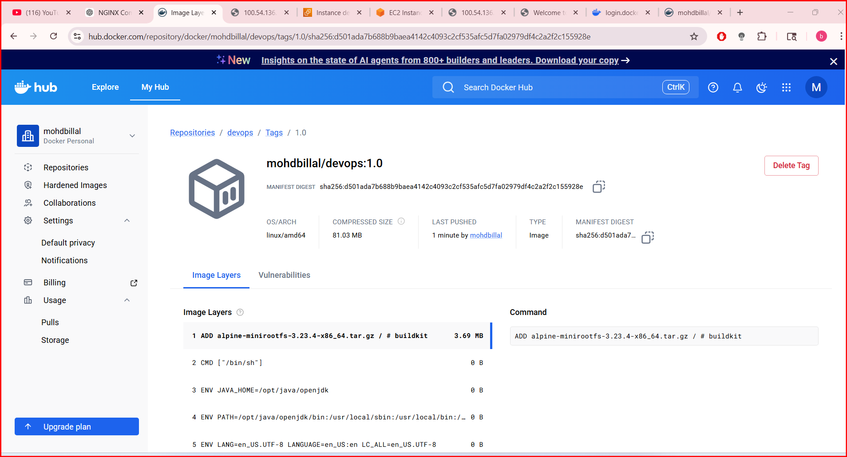
Conclusion
- Image scanning helps identify security vulnerabilities early
- Automated scans reduce the risk of deploying insecure images
- Integrating scanning with the registry strengthens overall container security

6. Implement solution to scan images when pushed to AWS ECR.
Step 1: Create or Identify an ECR Repository

- aws ecr create-repository \
- --repository-name devops \
- --region us-east-1
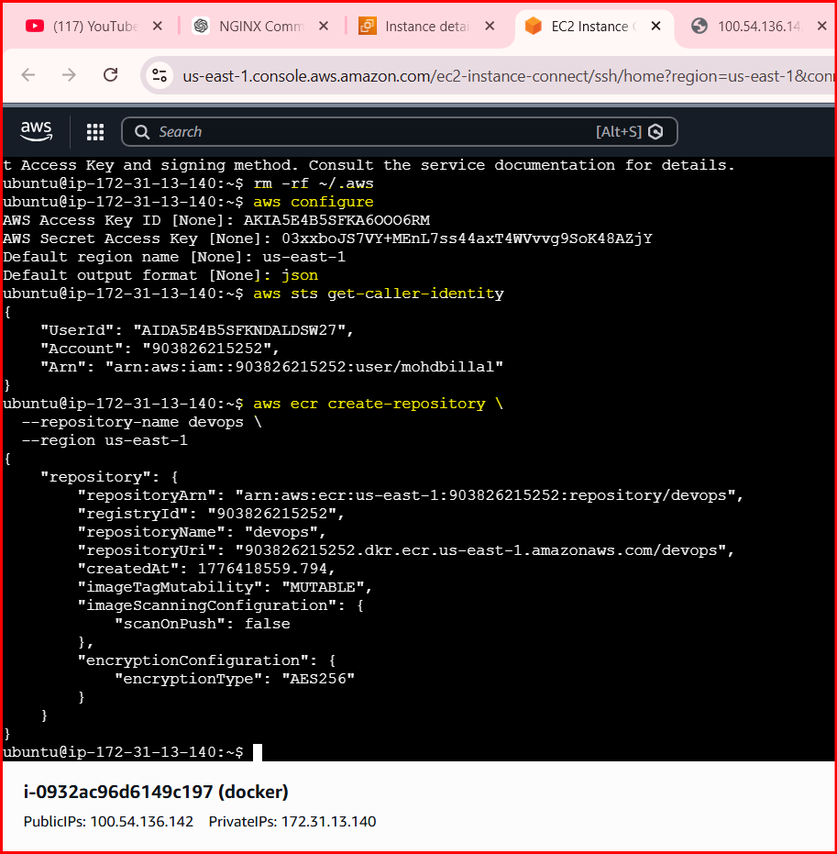
Step 2: Enable Image Scanning on Push
- aws ecr put-image-scanning-configuration \
- --repository-name devops \
- --image-scanning-configuration scanOnPush=true

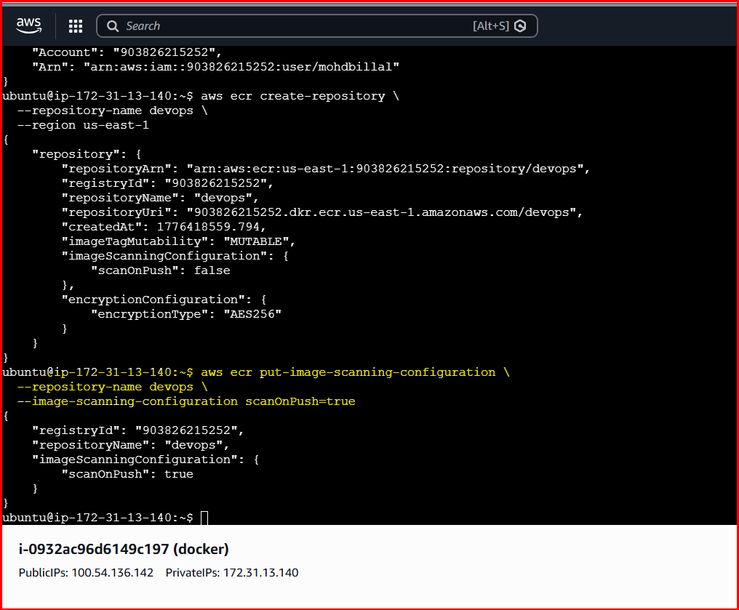
Step 3: Verify Scanning Configuration
- aws ecr get-registry-scanning-configuration

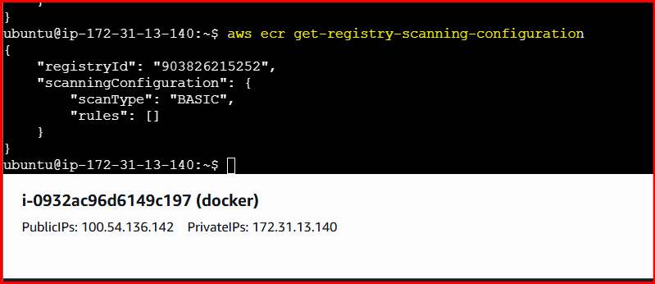
Step 4: Authenticate Docker to AWS ECR
- aws ecr get-login-password --region us-east-1 \
- | docker login \
- --username AWS \
- --password-stdin <account-id>.dkr.ecr.us-east-1.amazonaws.com

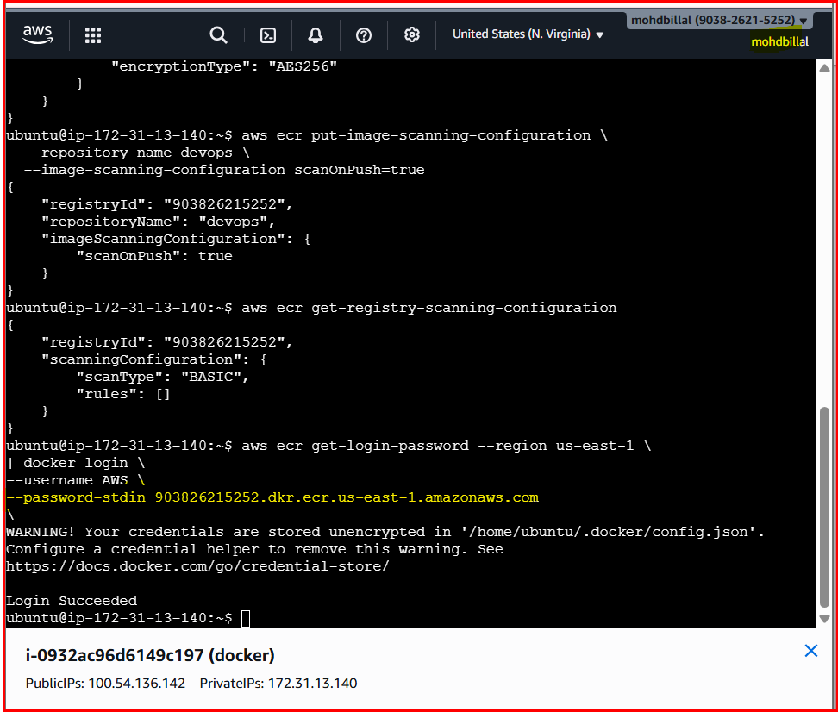
Step 5: Tag the Docker Image for ECR
- docker tag multi-stage-app:latest \
- <account-id>.dkr.ecr.us-east-1.amazonaws.com/devops:1.0

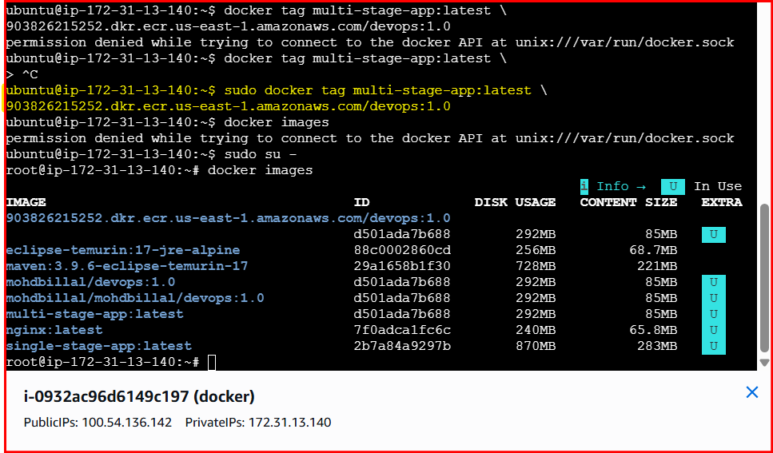
Step 6: Push Image to ECR (Triggers Scan Automatically)
- docker push <account-id>.dkr.ecr.us-east-1.amazonaws.com/devops:1.0
- docker push 903826215252.dkr.ecr.us-east-1.amazonaws.com/devops:1.0

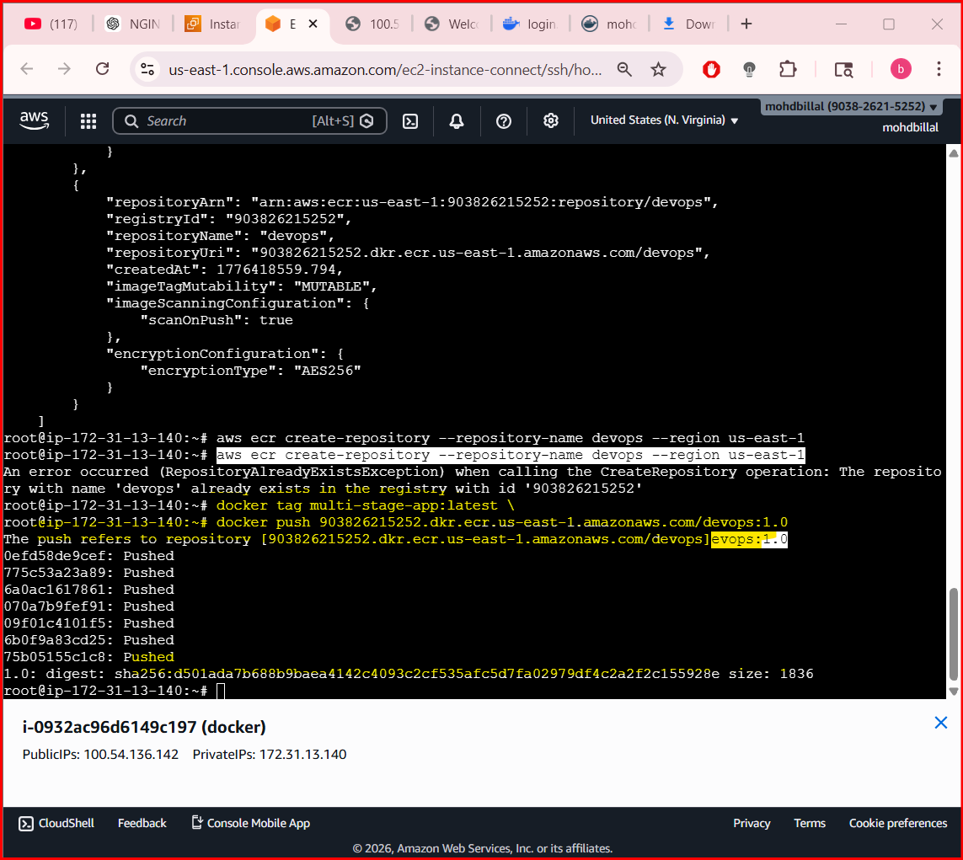
Step 7: View Scan Results in AWS Console
- AWS Console → ECR → Repositories → devops → Images

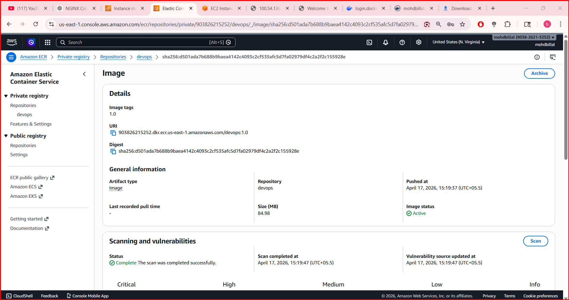
Step 8: Retrieve Scan Results Using AWS CLI
- aws ecr describe-image-scan-findings \
- --repository-name devops \
- --image-id imageTag=1.0
7. Create a Jenkins pipeline to create a docker image and push the image to Docker hub.
Prerequisites
1. Jenkins Agent Requirements
- Docker installed
- Jenkins user has permission to run Docker
docker –version
2. Docker Hub Credentials in Jenkins
- Go to:
- Jenkins → Manage Jenkins → Credentials
- Add Username with password
  - ID: dockerhub-creds
  - Username: Docker Hub username
  - Password: Docker Hub access token (recommended)
Step by Step implementation:
- Navigate to Docker hub and click on profile > account settings> and create PAT

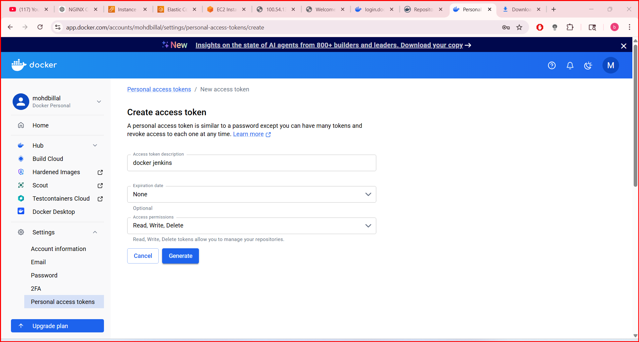
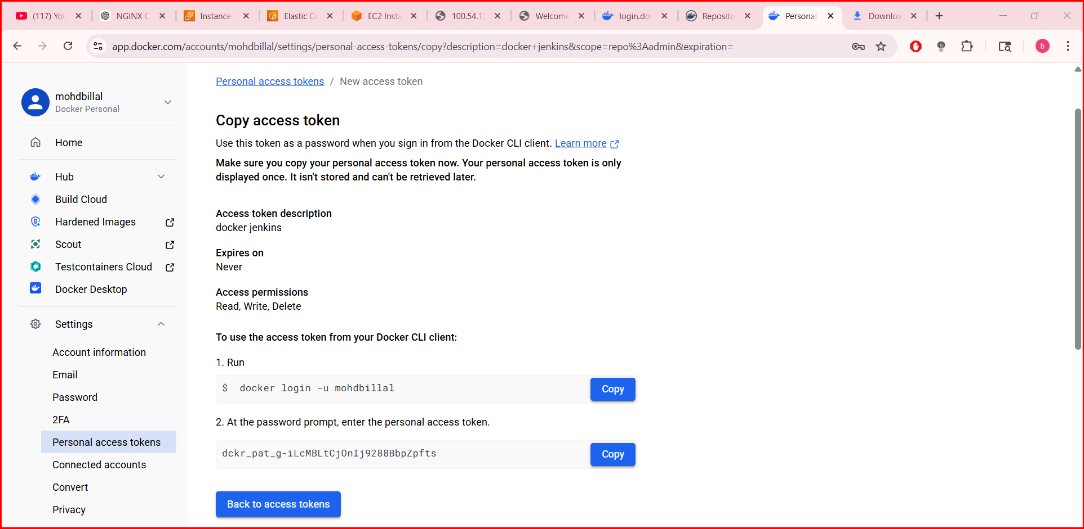
Step 3: install plugins of Docker
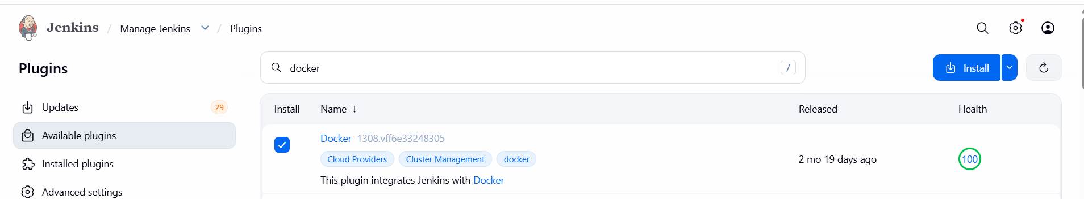
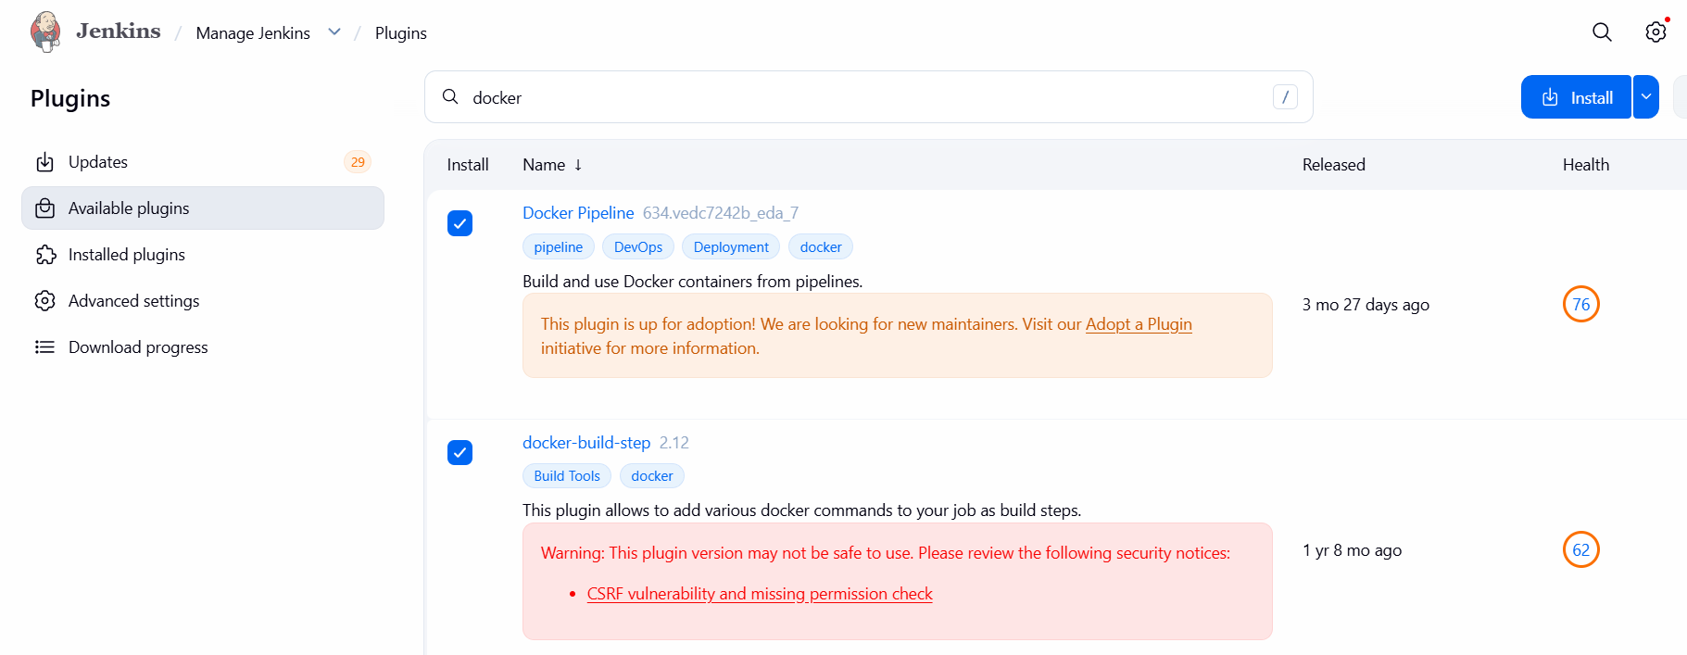
Step 4: Create a repository and add some files
Called
Add:
docker-pipeline/
├── Jenkinsfile
├── Dockerfile
└── index.html
Create Pipeline
New Item → Pipeline → Name: docker_job1
—-> attach the repo url
Branch as main*
Save
